|  |  |  |  |
| --- | --- | --- | --- |
|  |  |  | 1-FRET  2-FRET  3-FRET  4-FRET  5-FRET  6-FRET  7-FRET  8-FRET  🡨 OPEN STRINGS |
|  |  |  |  |
|  |  |  |  |
|  |  |  |  |
|  |  |  |  |
|  |  |  |  |
| + |  |  |  |
| - |  |  |  |

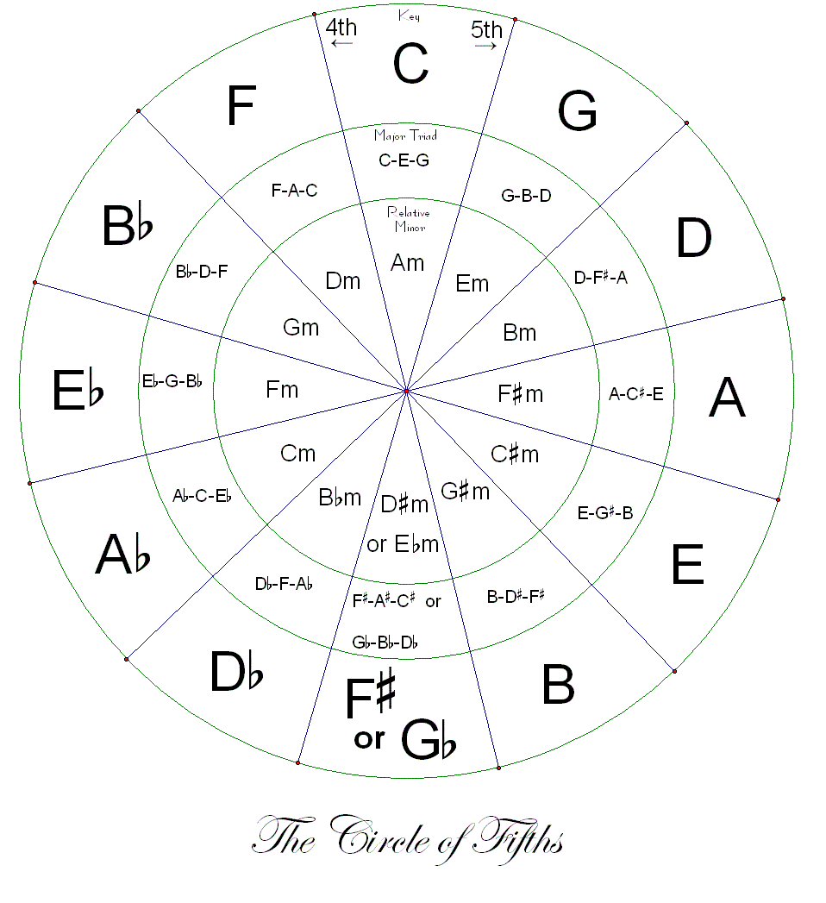

**There Is Power In The Blood Key: GShane and Shane - There Is Power In The Blood**

Verse 1

G C G

Would you be free from the burden of sin?

D G

There's power in the blood, power in the blood;

C G

Would you oe'r evil a victory win?

D G

There's wonderful power in the blood.

G

Power, Power,

C G

Wonder-working power

D7 G

In the blood of the Lamb;

G

Power, Power,

C G

Wonder-working power

D7 G

In the precious blood of the Lamb.

Verse 2

G C G

Would you be free from your passion and pride?

D G

There's power in the blood, power in the blood;

C G

Come for a cleansing to Calvary’s tide,

D G

There's wonderful power in the blood.